Economic Botany Collection
Royal Botanic Gardens, Kew

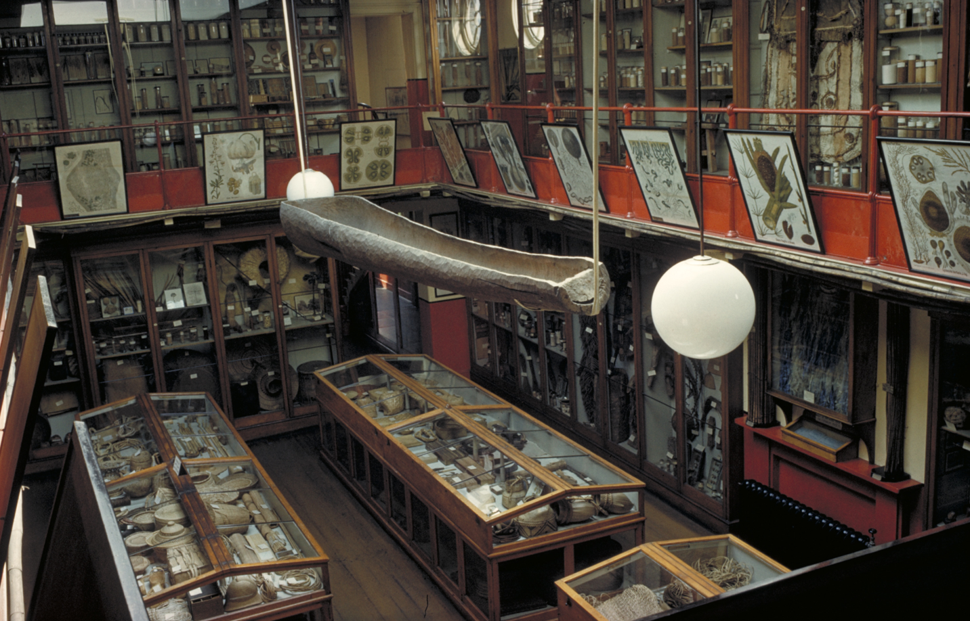

Research Guide

Version 3
December 2023

Table of Contents
Introduction 3
Essential reading 3
Access to electronic resources 4
EBC data organisation 4
Searching the EBC 4
Key Research Resources & Steps 5
Further Research Resources 8
Museum (of Economic Botany) records 8
Dispersed collections and Museum Exit Books 8
Museum Letter Books 9
Museum Guidebooks 10
EBC Banks Building – use by request through Kew staff 10
Records of previous research 10
EBC Library 10
EBC Files 10
Kew Gardens Library, Art & Archives 10
Library resources 11
Art 11
Archives 12
Additional Kew Collections & Resources 12
Living collections 12
Herbarium 13
Resources Outside Kew 13
Biographies and genealogy 13
Book catalogues 13
Full-text Publications 13
Pharmacy 14
Other Archives 14
Other libraries 14
Other Collections 15

Introduction
The Economic Botany Collection (EBC) at Kew is the successor to Kew’s Museum of Economic Botany, which opened in September 1847. Today it contains about 100,000 raw materials and products (henceforth referred to in this document as “objects”) either derived from plants or meant for plant use (for example, tea leaves and teapots).

Over the last two decades the EBC has formed the basis of many research projects and public engagement activities. Many outcomes from this research can be found in Kew’s Research Repository (https://kew.iro.bl.uk/), and listed at Economic Botany Collection‬ - Google Scholar‬‬‬‬‬: However, it is still the case that most EBC objects have not been the subject of detailed research since they arrived at Kew.

This guide sets out how to recover objects’ former contexts of production, use, collection, arrival, and display at Kew. It is organised in the order of intended use: how to find objects, and how to download their associated data, followed by a series of steps to enable the researcher to recover further core data. The section ‘Further research resources’ then takes you into the plethora of archival, library and online resources essential for in-depth research.

Where necessary, this guide should be used in conjunction with Economic Botany Collection: Introduction for Staff, Volunteers, and Interns, which explains the physical arrangement of the collection ― chiefly by Latin name with a few exceptions being large collections acquired recently. That document, along with this guide can be accessed on the Society for Ethnobotany’s webpage by following this path: https://ethnobotany.org/ > Education & Outreach > Biocultural Collections (http://ceeb.econbot.org/).

To access Kew’s collection in person, please contact ecbot@kew.org.

Note that the Kew Museum first opened in 1847. For eighteenth-century collections, such as those of Hans Sloane and Joseph Banks, most holdings are at the Natural History Museum, not Kew.

Essential reading
Cornish, Caroline. 2013. Curating Science in an Age of Empire: Kew’s Museum of Economic Botany. PhD thesis, Royal Holloway, University of London. This and Caroline’s other work can be downloaded from https://pure.royalholloway.ac.uk/portal/en/persons/caroline-cornish(a3c9179f-3367-4d10-920b-7f7919a39e03)/publications.html

Desmond, Ray. 2007. The history of the Royal Botanic Gardens, Kew. Free download: https://kew.iro.bl.uk/concern/books/4315ed47-42ad-4cb8-ba46-f65cd209af8e

Driver, Felix; Nesbitt, Mark; Cornish, Caroline. 2021. Mobile Museums: Collections in circulation.
UCL Press. Free download from: https://www.uclpress.co.uk/products/141630

Salick, J,. Konchar, K. and Nesbitt, M. (eds) 2014.Curating Biocultural Collections: a Handbook. Kew: Royal Botanic Gardens, Kew. https://kew.iro.bl.uk/concern/books/19d40fd7-edd4-4ea5-b178-9b42baf52859

Access to electronic resources
Availability is indicated thus:
No annotation = freely available
Plus sign (⁺) = on Kew’s computer network
Asterisk (*) = via subscription. Most subscription websites are available to members of university libraries and at the British Library. A very convenient route to remote access is by membership of the library at the Wellcome Collection: https://wellcomecollection.org/pages/YDaP2BMAACUAT7DS

EBC data organisation
The EBC was databased in the late 1980s, as part of a move to transfer the contents of the Kew Museum to the new collection store in the Sir Joseph Banks Building next to the Herbarium. In general, the database only includes information found with the object; no attempt was made at the time of transfer to cross reference objects to the Museum Entry Books (accession registers), nor to add in further information. The main purpose of the database is to act as a finding aid for the collection (like a library catalogue) and to preview collection data associated with that object. The database is not intended as a general information source about plants or ethnobotanical uses, nor as a complete source of information on objects. Though work over the past 20 years has illuminated portions of the collection, substantial further research is required to understand the full context of EBC objects.

Like Kew’s herbarium database, the EBC database is centred on botanical nomenclature. Note that the genus and species given in the databases may be the current accepted botanical name or may be a superseded name (synonym). Plant names are not updated in the EBC. If a search using an accepted name does not work, try a synonym. Synonyms can be found using Plants of the World Online.

Information searchable in the EBC database includes:
- Family name (Brummitt system)
- Genus and species (not necessarily current accepted names)
- Entry Book Number – crucial link to museum accession registers
- Collector and/or donor
- Collection and/or donation date

Searching the EBC
Currently there are three means available to search the EBC:

- Web catalogue https://ecbot.science.kew.org/
This gives a static view consisting of collection data and photos (of some objects) c. 2020 and does not include subsequent additions and updates. It is a crude interface that does not cope well with multi-word searches. It has no download facility. It works well for simple searches, e.g.:
- collector surname or institution name
- family (Brummitt system)
- genus and species
- country
- TDWG use
- catalogue number
The “Exclude Woods?” checkbox is broken, but the “Specimens with images” checkbox works.
- “Catching the Rain” Excel download http://catchingtherain.com/ecbot
This is a static download of collection data c. 2018. Its importance is that it enables download of collection data in Excel format, important for larger studies. Note that data field recognition is inconsistent and that downloads will need manual checking for consistency.
- Ecbot Management Database Available on Kew computers only
This is the only up-to-date record of the collection. It does not give access to images. Please see the Economic Botany Collection: Introduction for Staff, Volunteers, and Interns for details of access and use.

For a comprehensive search all three databases should be used, with both narrow and broad search terms. Diminishing returns will demonstrate when searching is complete.

Example search terms for a common plant such as tea could include: Camellia sinensis, Camellia assamica, Thea sinensis, Thea bohea, Thea viridis, Thea assamica, Camellia sp., tea, teaware, tea ware, tea, te, cha, chaa, etc...

Key Steps & Research Resources
In many cases it is most efficient to research Kew objects via the channels (e.g., collectors or institutions) by which they arrived at Kew. The first step is therefore to connect objects to their accession record in the Museum Entry Books. This (a) gives the details of the donor and the date of arrival at Kew and (b) shows what else arrived at Kew in that donation.

STEP 1 Find out the Entry Book Number (EBN) of the object, in the format 13.1851, i.e., the 13th batch of material to arrive in 1851.

With luck, the EBN will be in the catalogue record. If it is not, use the donor name or year of donation to locate the accession event in the Excel spreadsheet “Index to donors”. This is available from EBC staff or (for Kew users) in the relevant computer folder (Museum Entry Books).

The Museum Entry Books to 1924 are publicly available at: https://www.biodiversitylibrary.org/subject/Economic+Botany+Collection#/titles
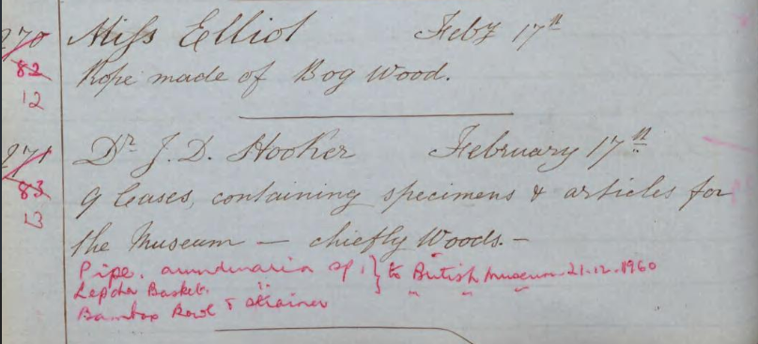
Here it can be seen that 13.1851 was accessioned on 17 February 1851, is from Dr J.D. Hooker, and comprises nine cases. Three items were transferred to the British Museum in 1960. This information provides a firm basis for further research.

Two major exceptions
Royal Pharmaceutical Society objects came to Kew in 1983. Full information about each object is held on index cards in the EBC. It is essential to consult these. It is usually possible to match cards to individual objects. When this is achieved, please add the relevant EBC number in pencil to the bottom right-hand corner of the card.

Harrod Collection (KCL/Chelsea College) came to Kew in 2012. Information from index cards has already been transferred to the database so it is not necessary to consult these.

STEP 2 Carry out searches on Google, Google Books, and Google Scholar to see if easily available information is available on the object(s).

STEP 3 Search Kew Bulletin (1887-) for any relevant information: https://www.jstor.org/journal/bullmiscinforoya⁺*
It contains Kew’s Annual Reports after 1881. Note the journal name changes over time.
1946-2017 -Kew Bulletin
1887-1941 -Bulletin of Miscellaneous Information (Royal Botanic Gardens, Kew)
1861-1882 -Report on the Progress and Condition of the Royal Gardens at Kew
1855-1858 -Sir W. J. Hooker's Report on Kew Gardens

STEP 4 Find any covering letter in Directors’ Correspondence (DC) - JSTOR Plants
About 60,000 letters (excluding Australia, Europe and UK) are digitised and summarised at JSTOR Plants: https://plants.jstor.org/⁺* Searching the summaries on this database are available to all users; high-res images are available to subscribers. This is a separate database to the more widely available JSTOR and very few institutions (mainly botanical gardens and plant focused institutions) subscribe. Full access and download are possible on Kew computers.

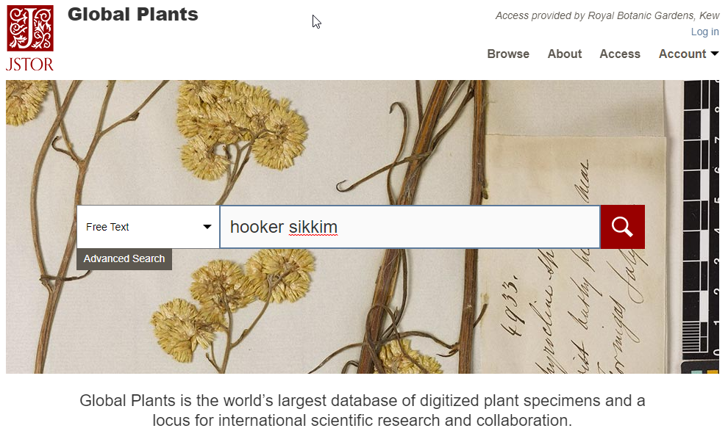

Choose the “Free Text” box and enter keywords. When results return, select “Collection < Directors’ Correspondence” to see letters. Note that for undigitized letters (e.g. British or Australian letters) you will need to ask Archives to check the card index to letters.

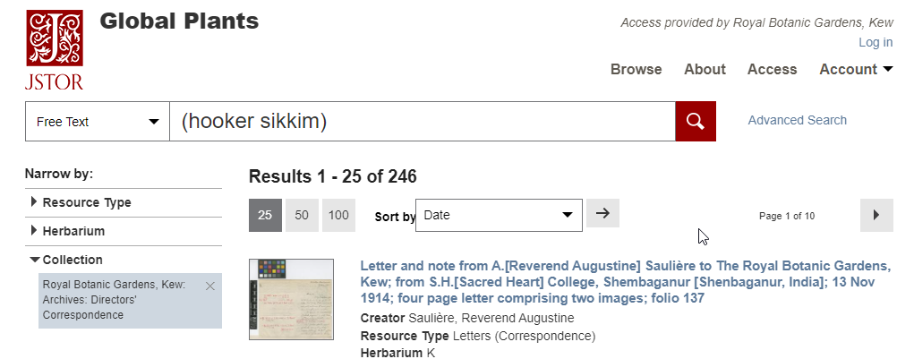

STEP 5 Check relevant files in Miscellaneous Reports (MCR)
These are bound volumes containing printed reports, correspondence and miscellaneous items, c. 1820-1928, relating chiefly to Kew’s relations with botanic gardens and other organizations overseas, with an emphasis on economic botany. There is an old categorization using “MR”, which is sometimes referenced, but no longer used. Refer to the current catalogue inventory, which uses “MCR” on Kew’s Archive Catalogue (http://www.calmview.eu/Kew/CalmView/advanced.aspx?src=CalmView.Catalog).
All MCR volumes have been digitised and all are available online (and on Kew’s computers) at https://app.wileydigitalarchives.com/ [uploading of volumes continues in 2023]

STEP 6 Check for printed material in the Kew Gardens Library
A fully retrospective catalogue (except for pamphlets) is held at https://kew.ent.sirsidynix.net.uk/client/en_GB/default/

STEP 7 Check for printed material at Google Books
This is a static collection of books, worth using for its good search facility. Note that only a minority of books are accessible via this platform. Google Books is no longer updated.

STEP 8 Check for printed material at archive.org
This is an actively developing collection of historic books. It can be difficult to search so:
- For journal issues, use the interface at Biodiversity Heritage Library (BHL)
- For known books, use the BHL or archive.org search interfaces
- For full text search, use: https://openlibrary.org/search/inside

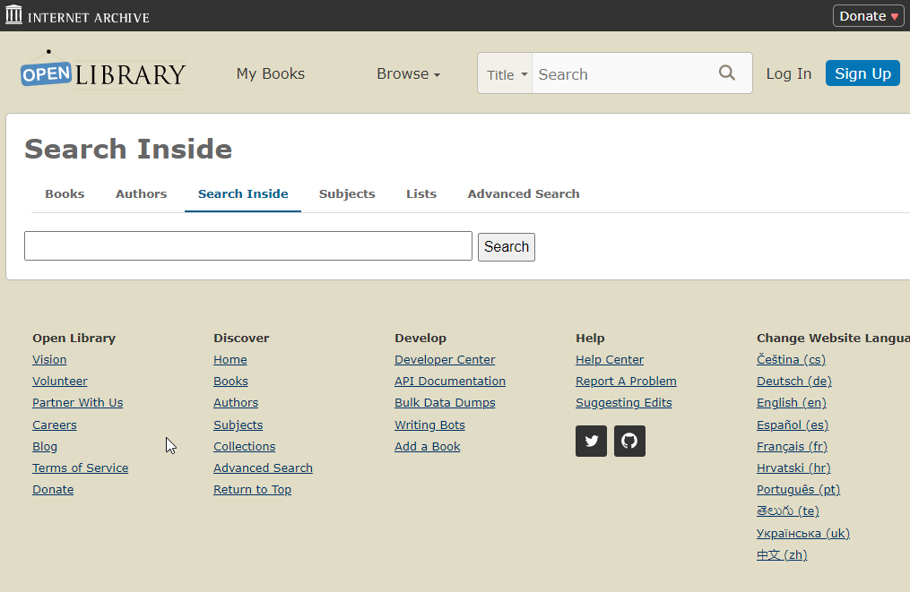

Further Research Resources
The above eight steps are the starting point for understanding the arrival of objects at Kew. A wide range of further resources is available:

Museum (of Economic Botany) records

Dispersed collections and Museum Exit Books
Since 1847 Kew has redistributed objects to other museums around the world, with particularly large dispersals in 1960-61. For research into Kew history or particular collections, it’s important to bear in mind that the relevant objects may no longer be held at Kew.

Some dispersals are noted in the Exit Books (aka “Specimens Distributed” books) and by annotation in the Entry Books. For more information, see:
https://www.rhul.ac.uk/mobilemuseum
where links to Exit books, transcriptions and other resources are available. Exits are discussed in more detail in this paper, available at the web site:
Cornish, C., & Driver, F. (2020). ‘Specimens Distributed’ The circulation of objects from Kew’s Museum of Economic Botany, 1847–1914. Journal of the History of Collections 32: 327-40.

Entry and Exit Books are available at: Biodiversity Heritage Library Note that they do not cover the 1960-61 exits.

Most of the 1960s dispersals went to these three museums:
British Museum - adding “Kew” to searches recovers all (or nearly all) objects transferred.
Horniman Museum - adding “Kew” to searches recovers an incomplete sample of transfers.
Pitt-Rivers Museum - adding “Kew” to “Other owners” recovers a sample of unknown completeness.

For the Horniman and Pitt-Rivers Museums the only sure way to find out what was transferred in 1960-61 is to look for the red annotations in the Entry Books. if a query is received about an object transferred in 1960-61, the steps are:
- Check to see if the object still bears a Kew label with its original entry book number (e.g. 55.1855). If so, refer to entry book for donor etc.
- If no entry book number, but the object bears a distinctive name such as ‘almanac’, search entry book transcriptions for that term.
- If no entry book number or distinctive name, look for a donor, then use donor index to review entry book records.

Most collections in regional museums, e.g., c. 250 straw-work items from Kew transferred to Luton Museum, are not online. Here the Exit Books, and other work on earlier distributions done for the Mobile Museum project, are important.

Note that for material transferred to Kew from the India Office Museum, formerly the India Museum (the museum of the East India Company), the slip books for all categories of material are held in the Textile Library at the V&A (staff library, not National Art Library). Former India Museum items at Kew can be distinguished by a pale blue paper disc affixed at the time of accession to Kew stating, “India Museum”.

Museum Letter Books
Record of letters in and out, kept in Kew Archives, not digitized. References to entries can be found in EBC catalogue records, typically in the format: year, volume number, page number.

School letter books
Letters received from schools and requesting teaching materials, are available at: https://www.biodiversitylibrary.org/creator/362#/titles
And are discussed in two open access papers:

Newman L, Plants on the move: Kew Gardens and the London schoolroom' in Mobile Museums: Collections in Circulation, 2021

Newman L & Driver F, 'Kew Gardens and the emergence of the school museum in Britain, 1880-1930' Historical Journal, 2019

Museum Guidebooks
Complete set 1855-1930s held in the Kewensia section of the Kew Library; some photocopies in Room 24, the researcher room in the Banks Building next to the curatorial office. Some are available online:
Museum of economic botany, or, A popular guide to the useful and remarkable vegetable products of the museum of the Royal Gardens of Kew (1855)
Official guide to the Kew museums. A handbook to the museums of Economic Botany (1861)
Official Guide to the Kew Museums: A Handbook to the Museums of Economic Botany (Second Ed., 1863)
Official Guide to the Kew Museums: A Handbook to the Museums of Economic Botany (Sixth Ed., 1875)
Official Guide to the Museums of Economic Botany. 1. Dicotyledons (1883)
Official Guide to the Museums of Economic Botany. 1. Dicotyledons (Third Edition, 1907)
Official guide to the museums of economic botany No. 2 Monocotyledons and cryptogams (1895)
Official Guide to the Museums of Economic Botany: No. 3. Timbers (1886)
Official Guide to the Museums of Economic Botany: No. 3. Timbers (1893)

EBC Banks Building – use by request through Kew staff

Records of previous research
- Electronic files on T drive (“Articles & Research” folder)
- Folders, theses, etc. in filing cabinets and on shelves in rooms 24 & 25.
- PowerPoints folder on T drive

EBC Library
There is a series of useful books in the EBC offices in the Banks Building, held as reference works for use only within the building.

EBC Files
- Images on T Drive [now almost all moved to Digifolia (dam.kew.org)
- Past EBC webpages, most useful for pharmaceutical collections such as Matson and Hanbury
https://web.archive.org/web/20130118051509/http://www.kew.org/collections/ecbot/collections/index.html

Kew Gardens Library, Art & Archives
Note that printed matter (Library), Archives and Art are curated by separate teams. Enquiries and requests to view must be directly separately (library@kew.org; archives@kew.org; illus@kew.org).

Aside from the catalogues listed above, see also Natural History Manuscript Resources in the British Isles (1980). LA&A Reading or Reference Room: B91(1.2). Still the most complete published summary of archives and art holdings at Kew.

Library resources
Kewensia - books, offprints and ephemera relating to Kew. Handlist held in Archives e-folder. Part of the library catalogue. The Kewensia section holds a more or less complete set of Kew’s annual reports (essential research tool), also online at:
https://www.jstor.org/journal/sirwjhookrepokew⁺* and
https://www.jstor.org/journal/repoprogcondroya⁺* (1855-82)
From 1887 annual reports are contained within Kew Bulletin and are thus online.

Economic Botany Library - Held in its own room on ground floor in the Herbarium. Key elements: red boxes (= museum files from 20th century), set of Pharmaceutical Journal, books and journals on useful plants.

Biographical pamphlets - in Library Stacks (old library), open access. These form the basis of Desmond’s essential book Dictionary of British and Irish Botanists (1994); copy in Room 24.

Exhibition catalogues - Kew holds one of the most complete sets of World’s Fair catalogues, including the hard-to-find detailed guides to individual courts (displays of a region or country). These can be found in the catalogue by searching on date and city and the word “exhibition”.

There is much information on the Kew Museum in these journals edited by Sir William Hooker:
London Journal of Botany 1842-48
https://www.biodiversitylibrary.org/bibliography/235
Hooker's Journal of Botany and Kew Garden Miscellany 1849-57 https://www.biodiversitylibrary.org/bibliography/236

Art
Most artworks are uncatalogued. They are held in three locations:
- In illustrations collection, mainly organised by plant family and genus.
- In Herbarium, interleaved with herbarium specimens. Can be located with advice from herbarium staff.
- Photographs are held by the same team in two series − a set of Economic Botany images arranged by genus, and formerly on display in the Kew Museum; and a subject series, including many pictures of botanic gardens worldwide.

Some images are catalogued and available in digital format:
- “Roxburgh” Indian botanical art, Wallich, Hooker, Burchell: https://www.watercolourworld.org/
- Oil paintings including Marianne North: https://artuk.org/
- Miscellaneous: https://images.kew.org/
- For Kew users, many artworks can be found on the internal image library, Digifolia.
- For botanical illustrations in books, see: http://www.plantillustrations.org/

Relevant contextual images (e.g. historic photos) can also be found at:
Wellcome images (hi-res, free for use)
Natural History Museum (med-res, some free for use)
National Portrait Gallery (hi-res, free for some use)
New York Public Library Digital Collections (hi-res, free for use)
Library of Congress Digital Collections (hi-res, free for use)
Rijksmuseum (hi-res, free for use)
Metropolitan Museum (hi-res, free for use)
Royal Commonwealth Society (in-person visit to Cambridge required)

Archives
In addition to the DC and MCR, described above, Kew’s Archives and Records Management (for modern records) teams look after a wide variety of other categories, mostly with no publicly accessible catalogue.

Kew’s Archive catalogue again is available online at http://www.calmview.eu/Kew/CalmView/advanced.aspx?src=CalmView.Catalog . A number of archive guides and handlists are available from Archives; EBC users should also consult EBC curatorial staff. Other archive series include:
- Kew Record Books/Index. These are being digitised and the first volume (1793-1809) is now available on BHL: https://www.biodiversitylibrary.org/item/305115#page/1/mode/1up
- Kew Inwards and Outwards Books. Records of living material and seeds received at and despatched from Kew, dating from 1793 until the mid-twentieth century.

Previous versions of archive finding aids can be found at:
https://web.archive.org/web/20160817084829/http://www.kew.org/learn/library-art-archives/archives/archive-collections
Updated copies are available from Archives but are no longer online.

Additional Kew Collections & Resources

Living collections
Hortus Kewensis. Auctore Johanne Hill (1768)

Hortus Kewensis - First edition
Volume I (1789)
Volume II (1789)
Volume III (1789)

Hortus Kewensis - Second edition
Volume I (1810)
Volume II (1811)
Volume III (1811)
Volume IV (1812)
Volume V (1813)

An epitome of the second edition of Hortus Kewensis...to which is added, a selection of suculent vegetables and fruits cultivated in the Royal Gardens at Kew. (1814)

Kew’s current living collection is housed in a Brahms database that is hard to use. it is advisable to send queries to the database manager, Tom Freeth.

Herbarium
Kew’s Herbarium catalogue is currently being migrated to a new data management system.

A more up-to-date set is available at:
https://www.gbif.org/occurrence/search?institution_code=K&occurrence_status=present

Resources Outside Kew

Biographies and genealogy
- Ancestry.com & FindMyPast, both freely available at the National Archives
- Oxford Dictionary of National Biography, available online via university or local library accounts
- World Biographical Information System (access via Wellcome Collection card)

Book catalogues
- Library Hub Discover (formerly COPAC) - books in UK research libraries https://discover.libraryhub.jisc.ac.uk/
- WorldCat - a global catalogue of books https://www.worldcat.org/
- JISC Historical Texts - multiple databases https://historicaltexts.jisc.ac.uk/home
  - British Library 19th Century Collection (BL) made available Jan 2021
  - Early English Books Online (EEBO)
  - Eighteenth Century Collections Online (ECCO)

Full-text Publications
Please refer to access advice on p. 2 and steps 7 & 8 above.

- JSTOR⁺* — long runs of journals and some books. Some free access. https://www.jstor.org/
- 19th-century British Library newspapers* N.B. The academic version omits many newspapers included in the commercial version at https://www.britishnewspaperarchive.co.uk/
- World newspapers*: https://newspaperarchive.com/ and https://www.newspapers.com/
- 19th-century UK Periodicals Series 1: New Readerships*
- 19th-century UK Periodicals Series 2: Empire*
- British Periodicals, Collections I & II*
- Illustrated London News Historical Archive* 1842–2003
- Early English Books Online (EEBO)* 1470-1700
- Eighteenth-Century Collections Online (ECCO)* 1701-1800
- Some libraries offer combined searching of some of these resources via Gale Primary Sources*
- House of Commons Parliamentary Papers (HCPP)* - includes much Kew and botanical content
- Who's Who & Who Was Who*

Wiley Digital Archives*:
- Environmental Science and History (including Kew’s Miscellaneous Reports), available on Kew computers at: https://app.wileydigitalarchives.com/wiley
NOTE: be sure to add Kew citation info to file names if downloading PDFs. These can be found by clicking on the citation tab and start with MCR, e.g. MCR/5/10/14. The citation info given at the top of each page is incomplete as it lacks this number.
- British Association for the Advancement of Science (Collections on the History of Science: 1830-1970)
- Royal Anthropological Institute
- Royal College of Physicians
- Royal Geographical Society Digital Archive

Pharmacy
The museum material from the Royal Pharmaceutical Society was often published in their journal, which has had a few title changes over the years:
‘Pharmaceutical Journal and Transactions’ from 1841 to 1895 (Series 1: 1841-1859; Series 2: 1859-1870; Series 3: 1859-1891)
‘Pharmaceutical Journal’ (Series 4) from 1895 to 1908
‘Pharmaceutical journal and pharmacist’ from 1909 to 1933
‘The Pharmaceutical Journal’ from 1933 onwards.

Kew holds a complete set of the journal in the Economic Botany Library. Much is online - see Dr Kim Walker’s links at: https://www.kimwalkerresearch.com/pharmacy-links

Other Archives
Some records held in local record offices, especially personal papers, can be found via the National Archives catalogue: https://discovery.nationalarchives.gov.uk/

A useful site to find additional archives is JISC Archive Hub https://archiveshub.jisc.ac.uk/

Other libraries
A useful site to find holdings in other libraries is JISC Library Hub https://discover.libraryhub.jisc.ac.uk/

Anthropology Library, British Museum
Comprehensive holdings with books on open shelves and series/serials on request. Articles are indexed at Anthropological Index Online

British Library
Comprehensive access to book and online resources. Also the archives of the East India Company and India Office, partly digitised for botany. See also this guide: Science and the Changing Environment in India 1780-1920 by Richard Axelby and Savithri Preetha Nair (London: British Library, 2010).

Linnean Society
Diverse archives, books and botanical specimens.

Senate House Library
Outstanding open shelf collections on economic and political history and travel in Commonwealth and empire.

Guildhall Library - The Library of London History
Guildhall Library holds internationally renowned collections of books on family and local history, wine and food, Samuel Pepys, John Wilkes and Thomas Moore, plus the libraries of the Clock Makers', Gardeners' and Fletchers' Companies, the Antiquarian Horological Society, Gresham College and the Charles Lamb Society.

Archive collections, managed by London Metropolitan Archives and accessed at Guildhall Library, include the archives of 80 City livery companies, the Lloyd's Marine Collection and the London Stock Exchange, as well as many businesses.

Victoria & Albert Museum - National Art Library
Holds the UK’s most comprehensive public reference collection on fine and decorative arts, etc including materials regarding South Kensington Museum and the former India Museum located in London which closed in 1879.

Biodiversity Information Standards. TDWG stands for Taxonomic Databases Working Group, which was the former name of this organisation.

